AQUITANIMA INTERNATIONAL ANGLO-ARABIAN SPORT TOUR 2018
Bordeaux, Nouvelle-Aquitaine from 9th to 12th of May 2018

Flat-rate contribution
400€/person (on the basis of a single room)

FOR PAYMENT, PLEASE PROCEED WITH A TRANSFER TO INTERCO NOUVELLE-AQUITAINE BEFORE 09/04/2018
Bank: Banque Populaire Aquitaine Centre Atlantique
Allée de Tourny – 33000 BORDEAUX
Account number: 72021014859 57

International Bank Account Number (IBAN): FR76 1090 7000 0172 0210 1485 957
Bank Identification Code (BIC): CCBPFRPPBDX

The Anglo-Arabian Sport Tour includes
 Reception at the airport and transfer to the hotel on Wednesday, 9th of May
- Transport by bus to technical visits, hotel and fair
- Hotel for 3 nights from Wednesday the 9th to Friday the 11th of May included
- International seminar
- Lunches and dinners during the program of technical visits
- Accompanying and translation support
- Entrance tickets to the fair
 Full access to the international stand

Reservations are managed by INTERCO Nouvelle-Aquitaine

AT YOUR CHARGE
Your trip to Bordeaux and personal expenses
The night of Saturday 12th of May (INTERCO is in charge of the reservation)

I authorize the organizers to use my image for all visual communication medium □ yes □ no
(Photos tours and fair)

Contact us
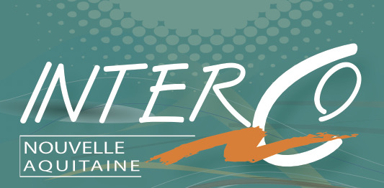 Hélène LOPEZ - + 33 (0)5 56 10 19 15 – Email : Helene.Lopez@interco-international.com
Tamara Villarruel - +33 (0)5 56 10 19 18 – Email: tamara.villarruel@interco-international.com

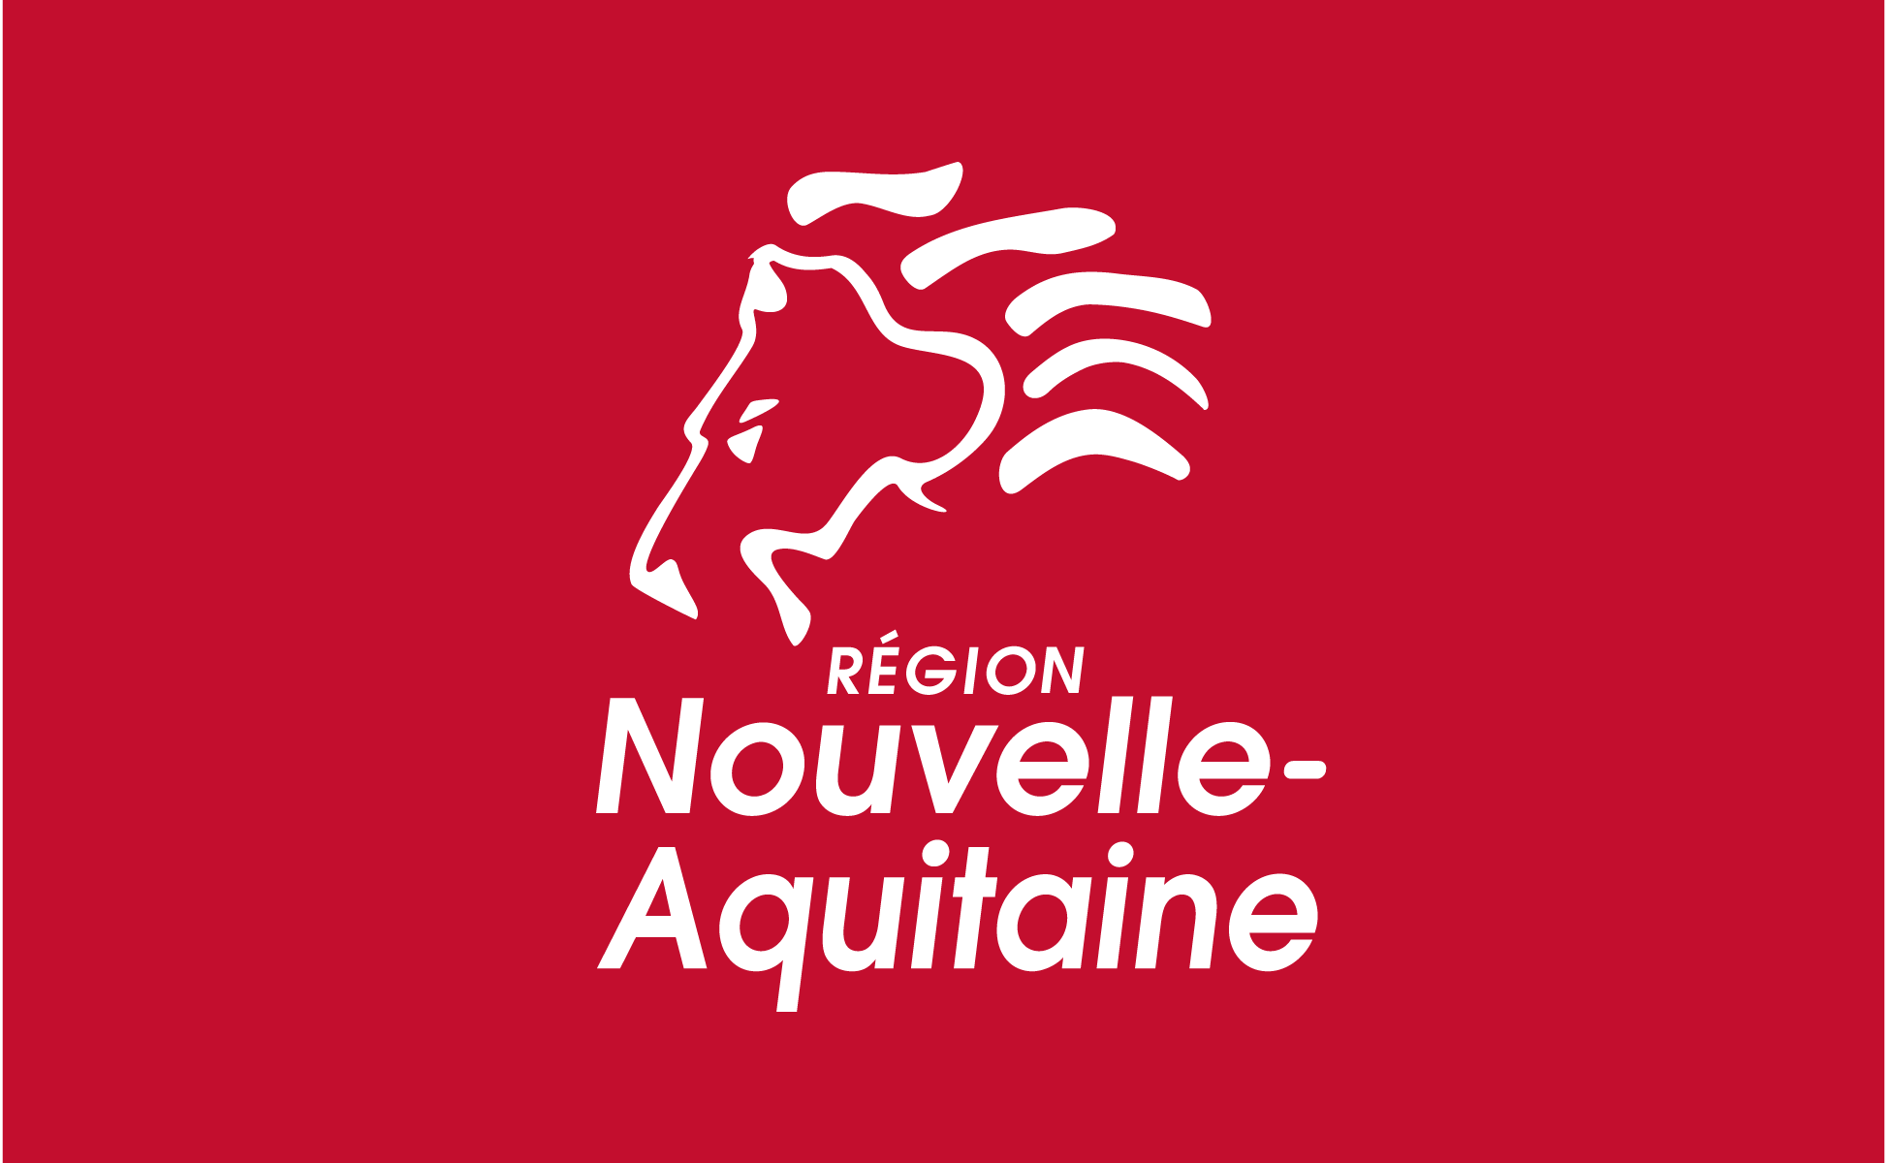

 |  |  |  | REGISTRATION FORM
Company:
Activity:
Contact :
Function:
Address:
City: |  |  |  |  |  |  |  |  |  | ZIP Code:
Country:
Tel:
Cellphone: |  |  |  |  |  |  |  | Fax :
Email :
Website:
Type of breeding
Breed(s) raised:
Number of animals (including mothers) :
Reproduction : |  |  |  |  | natural servicing insemination
LOGISTIC INFORMATION
Day (mm/dd/yyyy) and arriving time:

Day and arriving time:

By which means of transport will you arrive?
Departure city, flight number
Connections
Flight number
Type of room |  |  |  |  |  | single double twin
Person’s name sharing the room

TO RETURN TO THE INTERCO by email: interco@interco-international.com or by fax : + 33 5 56 10 19 13

